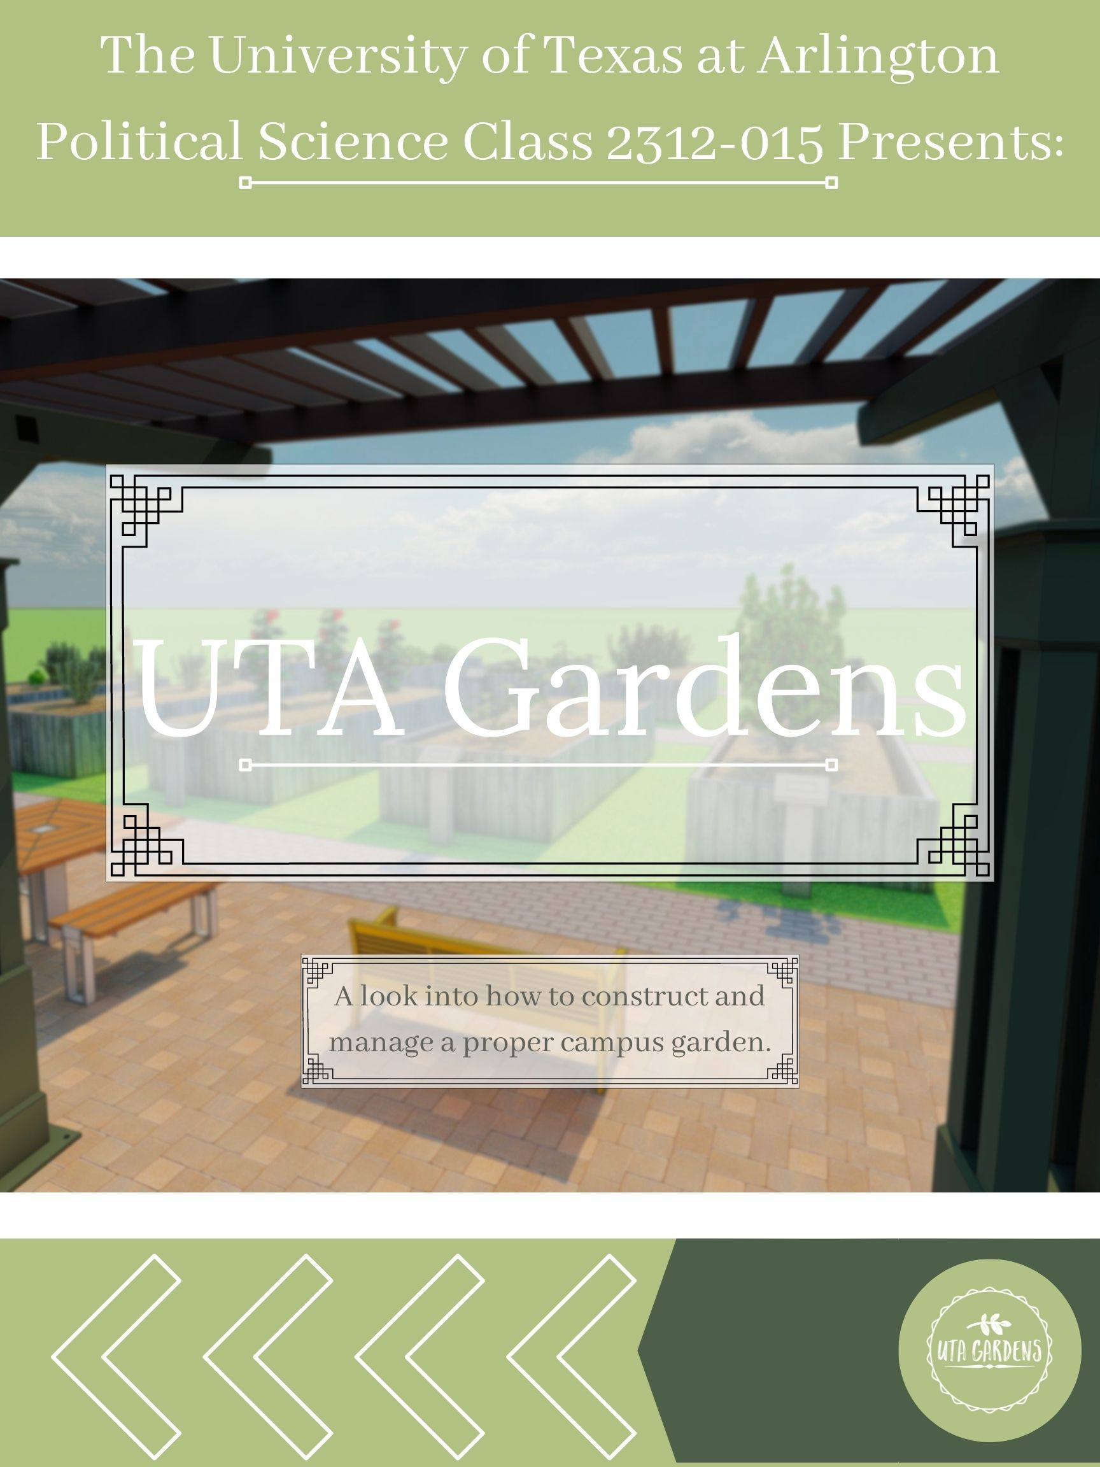

**Written By:**

|  |  |
| --- | --- |
| Faith Beene | Audrey Miller |
| Aindrila Bhattacharya | Christine Park |
| Hannah Brantley | Alexis Pedraza |
| Aarti Darji | Kiersten Powell |
| Alexander Ginter | Trevor Reigh |
| Avery Gray | Bailey Samide |
| Garrett Henderson | Victoria Satterwhite |
| Ryan Lahlou | Isabelle Utter |
| Makayla Lucio | Tiffany Vargas |
| Aryan Mediratta | Zachary Xayaphanh |





**Acknowledgements**

Bhargavi K Jeyarajah, Sustainability Coordinator, Office of Sustainability, UTA

Alexis Perez, Emergency Assistance Coordinator, Maverick Pantry, UTA

Lauren Wardwell, President, American Society of Landscape Architects, UTA

Meghna Tare, Chief Sustainability Officer, Office of Sustainability, UTA

Wendy Pappas, Head of Community Garden, UTA

Maria L Cardenas, President, Campus Cat Coalition, UTA

Dr. Rebekah Chojnacki, Honors College Program, UTA

Dr. Jason Hogue, English Professor, UTA

Hector Rivera, Student Assistant, Office of Multicultural Affairs, UTA

**Abstract**

The University of Texas at Arlington (UTA) is a fresh food desert. This reflects the lack of accessibility of fresh food in the area. We conducted several polls and interviews among students and faculty members at UTA to analyze the problem. An emerging desire for easy access to fresh foods and produce on campus was observed. This paper proposes a project to build new gardens and green spaces on campus. The underlying objective is to make UTA an edible campus.

The team identifies a few similar initiatives nearby and distinguishes between the needs of the university and the purpose those projects seek to fulfill. We seek to collaborate with and integrate the project with other university initiatives such as the Maverick Pantry and the Sustainability initiative. The paper further intends to layout implementation plans and set goals for the project.

**Why UTA Should Have a Garden**

Lack of Green Space

Currently, there are not a lot of green spaces to be found throughout UTA’s campus. The few green spaces on campus include Davis Street Greenbelt Park, Doug Russel Park, and Green at College Park. This can prove to be detrimental as studies have shown that green spaces reduce the risk of developing mental health disorders during childhood continuing through adulthood (Rocchio, Carlowicz 2019). A study performed by Denmark’s University of Aarhus tracked the amount of green space around an estimated 1 million people and compared it to their mental health. Through this, researchers found that those who grew up and lived in an area without much green space had up to a 55% increased risk of having or developing disorders such as “depression, anxiety, and substance abuse in later years” (Rocchio, Carlowicz 2019). The importance of having green space may seem like it is most necessary in childhood; however, the effect of green spaces has proven to be dose-dependent or more significant with more prolonged exposure. With college life being stressful for students, having more green space on campus can add to health benefits for college students and faculty.

Sustainability on Campus

Currently, the Office of Sustainability on campus is known for its composting efforts (see fig.1). This program composts 30 tons of waste on campus every year. When decomposing in a landfill, this waste releases greenhouse gas 21 times more harmful to the environment than carbon dioxide. As of right now, one person operates this facility. Sustainability Coordinator Bhargavi Jeyarajah is working to establish a volunteer program to help these efforts.

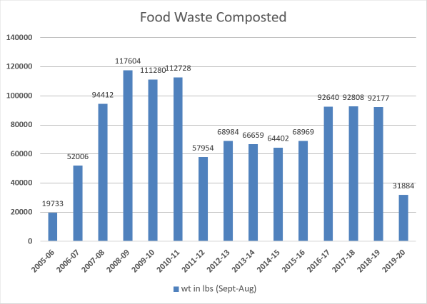

Fig.1. Food waste composted from UTA Sustainability. “Community Garden and Composting.” *UTA Sustainability*, 13 May 2021, https://sustainability.uta.edu/community-garden-and-composting/.

Jeyarajah said we could use their facility’s compost for our current project, but she was unsure about edible plants. During our interview, we gathered her belief that the garden would become “the heart of sustainability projects” and a space to “volunteer, socialize, and have healthy food.” The garden, she also noted, would have the added benefits of “reducing food miles and being a carbon sink.” (A carbon sink is anything that absorbs more carbon than it releases.) This is great for the environment because 45% of the excess carbon humans produce in the atmosphere. This warmed the atmosphere and caused temperatures to rise by 0.6 degrees Celsius (1.4 degrees Fahrenheit) since 1880 (see Fig.2). (National Aeronautics and Space Administration (NASA))

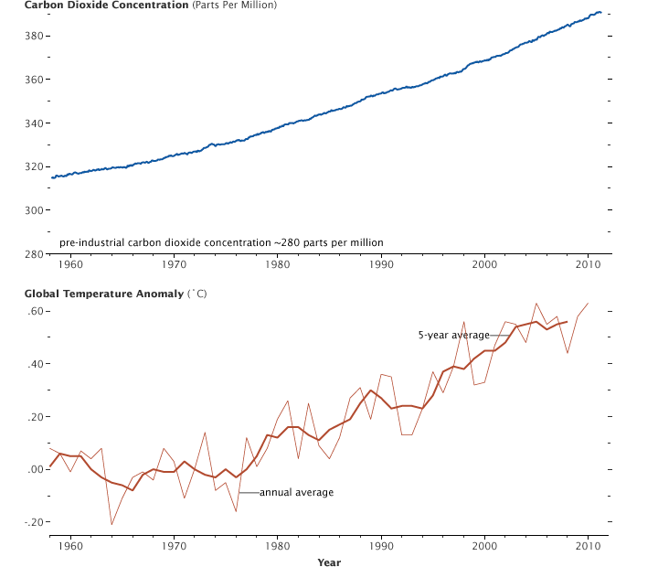Fig. 2. Carbon Dioxide Concentration (ppm) from “The Carbon Cycle.” *NASA*, NASA, 16 June 2011, https://earthobservatory.n22asa.gov/features/CarbonCycle/page5.php.

Fig. 3. Global Temperature Anomaly (in oC) from “The Carbon Cycle.” *NASA*, NASA, 16 June 2011, https://earthobservatory.nasa.gov/features/CarbonCycle/page5.php.

Along with the environmental benefits and sense of community, Jeyarajah mentioned the psychological benefits greenery is proven to produce. The combination of physical activity, social interaction, sunlight, and nature makes gardening healthy for both the mind and body. Sunlight helps lower blood pressure while maintaining vitamin D levels. The community coming together to garden can help counter social isolation for those with mental health issues or disabilities. Moderate exercise regularly can “reduce the risk of dementia, mental health problems, cardiovascular disease, diabetes, and cancer of the breast and colon.” In a study conducted in Australia, gardening proved more effective than walking, education, and moderate alcohol intake in dementia prevention (Thompson).

Some studies were conducted with participants before and after gardening. These participants had a reduction in depression and anxiety symptoms. Repeated gardening has been proven to reduce stress, BMI (Body Mass Index), and depression severity while increasing life satisfaction, cognitive function, and general health (Garcia, 2021).

Food Desert

The University of Texas at Arlington (UTA) is a food desert. It is imperative to have accessible transportation to get food for students living in a dorm room or apartment on campus. The Connection Café has fruits and vegetables; however, these options are limited and unappetizing. In the poll we sent out to faculty and students, 68.2% of the respondents, or 122/179 people, answered they did not feel fresh food was accessible on campus (see fig.5).

To combat issues with food availability on campus, the Maverick Pantry was established this semester. This new project means students can get ten items upon presenting their ID and submitting a request by emailing Alexis Perez, the Emergency Assistance Coordinator. However, the food is nonperishable and not fresh as of December 2021. Upon interviewing Perez, we found that the Maverick Pantry has helped 450 students already this semester. Their goal as an organization, according to Perez, is to “feed student success and relieve stress caused by food insecurity.” Perez fervently supports this project because it will encourage healthy lifestyles and sustainability on campus. The Pantry wants to have fresh produce available to the students, and a project such as this, will “relieve the logistics aspect of delivering produce” to them.

Current Garden Managed by the City of Arlington

The City of Arlington already has an established garden located not too far from campus. However, the garden does not fit our desired needs. We interviewed Wendy Pappas, the head of the community garden, and asked how the garden was available to the public. She responded that the garden’s primary agenda is to have plots of land available for people to rent. Families, professors, graduate students, and everyone else who wants an opportunity to grow their foods are welcome. However, their focused demographic is not UTA students seeking fresh fruits and vegetables. Currently, there is a year-long waiting list for a single plot of the garden. Because of this extensive wait, the City of Arlington does not advertise the garden on social media. Most students had not heard of the garden, or if they had, they were unsure how it functioned or how to get involved.

The garden has tools available to rent, but seeds are not provided. The multicultural aspect of the garden flourishes as many of the gardeners plant food that remind them of home. Despite the vibrant assortment of produce, the primary problems patrons run into are other gardeners. Pappas handles complaints almost daily. Conversely, critters and weather are handled organically: no pesticides or shelter is deemed necessary by the City of Arlington. Bermuda grass requires mowing regularly, while extreme weather calls for consistent upkeep from staff. 100-degree summer heat demands watering multiple times a day, and freezing temperatures necessitate checking the water pipes. Soil and mulch must conform to specific gardening regulations, and the garden must be accessible to those with disabilities.

Initially, the garden was paired with a committee and classes for the general public. Over time, the committee fell apart due to a lack of communication and organization. The classes lost attendance fast despite their original popularity. Pappas emphasized the hardships of running the garden. Volunteers, however, have been an enormous help in maintaining a clean, beautiful garden. Students from UTA volunteer once a month to pick up trash, organize supplies, and tidy up the area. The garden is a volunteer in a way as well. One of the requirements of renting out a plot is to donate half of the harvest to Mission Arlington, a nonprofit organization devoted to serving the community. The interview was beneficial in learning what worked and what failed for the community garden. Pappas voiced that she would be willing to donate manuals and help implement an on-campus garden focused on providing fresh produce to UTA’s students.

**Statistics**

Poll Results

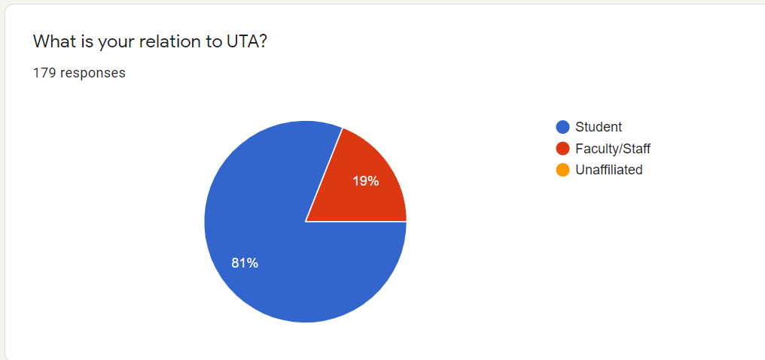

Fig. 4 Relation to UTA poll

81% of respondents were students and 19% were faculty members at UTA.

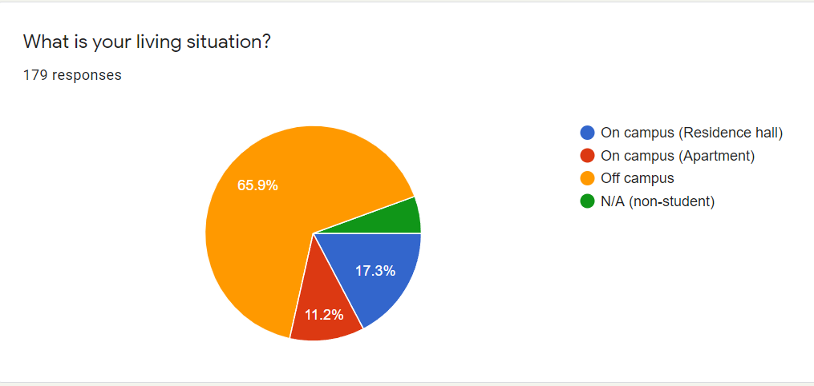

Fig. 5 Living Situation Poll

65.9% of the 179 respondents live off-campus, 17.3% live in a residence hall, 11.2% in apartments, and the remaining are not students.

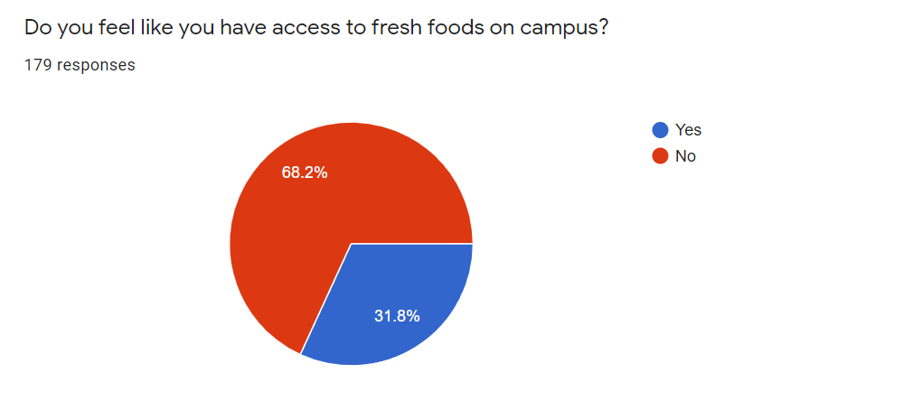

Fig. 6. Access to fresh foods on campus from Campus Opinion Poll

68.2% of respondents believe they do not have access to fresh foods, and the remaining 31.8% believed fresh food was accessible.

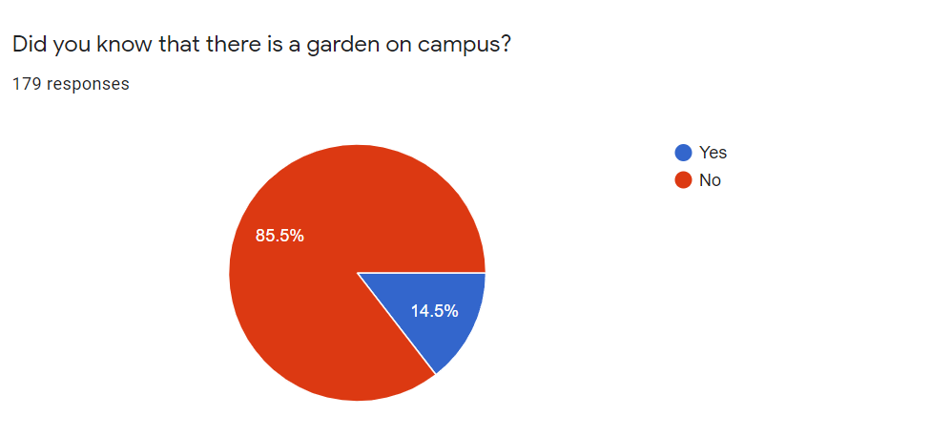

Fig.7 Current Garden on Campus Awareness Poll

85.5% of the 179 respondents were not aware of the current garden that is run by the city and UTA.

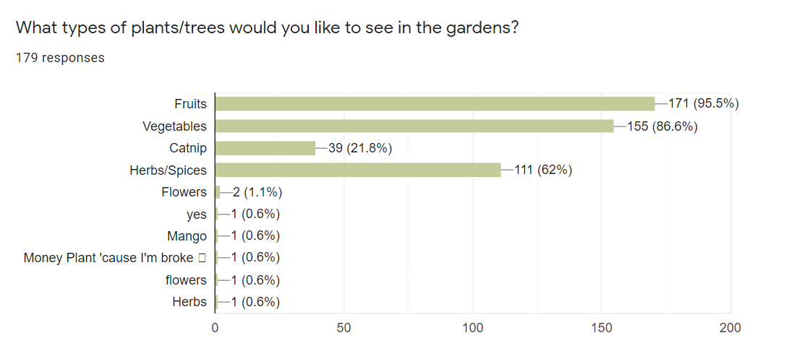

Fig.8 Plants and Trees Wanted in Garden

95.5% of students want fruit in the garden, 86.6% want vegetables, 62% want herbs and spices, and 21.8% want catnip.

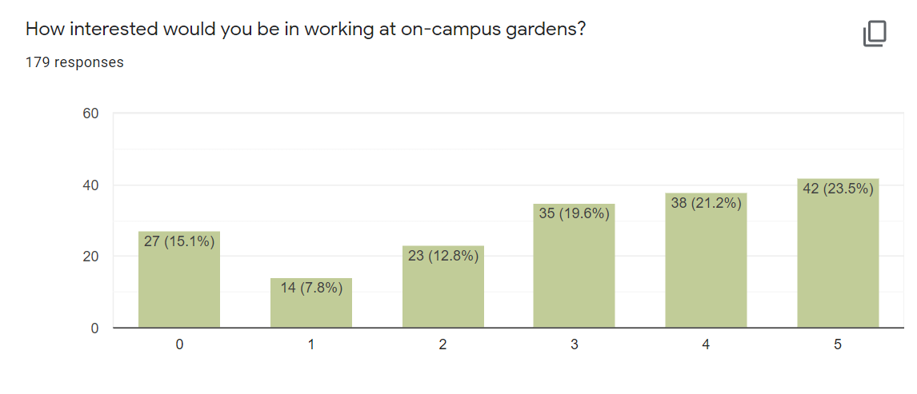

Fig.9 Interest in Garden Work

On a scale of 0-5, 5 being most interested, 23.5% were very interested in volunteering at a garden on campus, 21.2% were interested, 19.6% were sort of interested, and the remaining were not as interested. In total, 64.3% of those surveyed were interest in helping work at the garden.

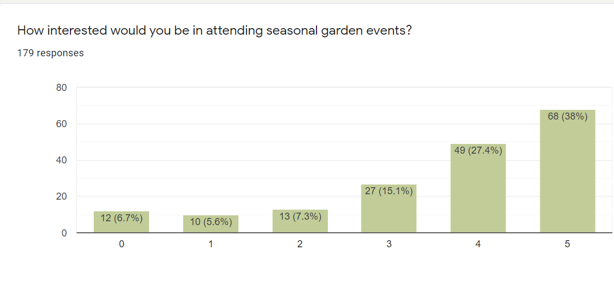

Fig.10 Interest in Garden Events

On a scale of 0-5, 5 being most interested in attending a seasonal garden event, 38% were very interested, 27.4% were interested, 15.1% were sort of interested, and the rest were not interested. In total, 80.5% showed interest in garden related events.



Fig.11 Gardening club interest

On a scale of 0-5, 5 being most interested in joining a gardening club, 24.6% were very interested, 17.9% were interested, 17.3% were sort of interested, and the remaining respondents were not interested. Out of the 179 respondents, 59.8% were interested in joining a gardening club.

Other Colleges' Garden Data

The University of Texas Austin (UT Austin) Concho Community Garden was initially constructed in 2011 as part of the Green Initiative. Meaning, it is a project funded by charging a $5 fee with tuition each semester. In 2015, the garden was renovated and now has 40 raised garden beds. 15 of these garden beds are used by the community and grow native plants. Every year, the garden has just over 1,000 volunteers visiting to help maintain it on Tuesdays from 5-8 PM and Saturdays from 10 AM-1 PM. Garden leadership classes are also taught to 80 kids from the UT Child Development Center. All these successes were made possible with adequate funding and collaboration of organizations from UT Austin and the city in general.

**The Proposal**

Design

Fig.12.

When designing a garden, a variety of factors must be considered. Depending on the plants desired, factors such as soil depth, soil composition, and a plant’s water requirements are crucial to consider. There is no “one size fits all” strategy for designing a garden. Lauren Wardwell, the president of the American Society of Landscape Architects here on campus, provided some fundamental suggestions and information regarding how to go about planning such a project. During the interview, she discussed many different ideas and concepts for implementing an on-campus garden. It is intended to be a functioning garden while still allowing for a pleasant green space for students to use.

Raised bed gardens were decided as the best fit for the project. They allow the gardens to be more individually catered to the plants installed. By raising the beds, the choice of the soil composition and determining the depth of the soil to suit the species involved becomes more inclusive, as certain plants have deeper root systems. Maintenance is another big concern for the garden’s longevity, and using raised beds significantly helps with this. For starters, raised beds allow for significantly fewer weeds, saving nutrients for the plants, as well as time for the potential caretakers. Watering the plants is another big concern for maintenance. With the raised bed system, there would be many separate beds, facilitating the ability to water each type of plant to its appropriate tolerance properly. Ms. Wardwell recommended the idea of using a drip-feed irrigation system, as it would allow for a more consistent and healthier distribution of water to the variety of life living in the gardens. This would also help take some weight off the shoulders of the garden caretakers to water each bed to its correct amount and schedule appropriately. Another beneficial aspect of the raised gardens would be the diversity of location possibility. We have a vast and beautiful campus, but not every location would be suitable for growing and developing a garden. With raised beds, the garden could be placed anywhere with adequate space.

Fig.13.

booba gaga


Fig.14.

To develop the garden’s aesthetics, Ms. Wardwell suggested implementing seating areas and proper walkways to make the area easily accessible to students. With many different seating areas on campus, it was decided that the garden would want to blend in with the existing architecture. Near Cooper Street, benches and pergolas are present; these are a beautiful part of our campus. This concept inspired the conceptual seating area adjacent to the garden. This region would be benches and picnic tables with the potential for charging stations, like what is found next to the University Center. Utilizing the various aspects and elements from around UTA’s campus would help tie the garden to the already realized space without heavily clashing and standing out. Tied into this would also be a small shed designed to store tools and other necessary supplies for the garden’s wellbeing. This solves any concerns for storage and accessibility of tools for garden members. Another helpful recommendation from Ms. Wardwell was implementing signs next to each bed with descriptions of what was currently being grown to help educate or inform curious passerby. Attached are images of a conceptual rendering of the potential of the garden, including various design choices and architectural elements.

Potential Locations

We met with Professor Meghna Tare, an Adjunct Assistant Professor at UTA and UTA’s Chief Sustainability Officer, about putting a garden on campus. We tried to discuss details such as where we could potentially implement the garden and how it could help grow food that could better sustain our campus. Professor Tare opened our eyes to the hardships of our ideas and what we needed to consider before moving forward.

Our class took her suggestions to heart and focused on tweaking the concrete proposal for our garden. As a group, we brainstormed multiple locations on campus to implement the garden, which was difficult because most places on campus have minimal space. The best area to implement the garden would be on the west side of campus, between the Maverick Activities Center (MAC) and the tennis courts. This area has a fair amount of open space and can encourage more people to hang out or study on the west side of campus. One major pro of this location is that it is very close to West Hall and the apartments on campus, making it easily accessible to students. Students living in Vandergriff, Arlington, or KC Hall are just a short distance away from this area.

With the undertaking of this project, it is crucial to understand the responsibilities of creating and maintaining this space. To help understand this, we interviewed UTA’s sustainability coordinator, Bhargavi Jeyarajah. When asked about how to get this started, Jeyarajah answered that talking to someone in landscape architecture would help make this garden sustainable. Along with this, Jeyarajah said that the garden could be an opportunity for volunteers to handle the construction and upkeep.

Potential Plants by Seasons and Cost Analysis

Space availability, as well as plant size, are important factor to consider when selecting optimal plants to grow in a raised bed garden. Additionally, cost, care (i.e., watering, susceptibility to diseases and pests, soil maintenance, etc.), hardiness, and yield are important factors. We considered these factors to select some plants for each season that are well-suited to be grown in Texas.

Spring:

There are many popular spring plants that could be grown fresh for students. Sweet corn, cucumbers, melons, peas, spinach, and tomatoes are popular plants optimal for spring planting.

Sweet corn is very popular due to its flavorful and sweet kernels. It also has cultural growing techniques used by the Native Americans associated with it. The technique used was called the Three Sisters in which corn, beans, and squash are planted together with corn serving as the support for the bean vines, the beans act as a fertilizer for the corn and squash, and the squash takes up ground space to keep weeds away, so corn could be used in tandem with squash and beans to be a culturally enriching experience for students. Things to be wary of however are that it can lose its sweetness if stored for more than only 2 days which can lower its appeal, so it may need to be announced in advance if corn is grown. Corn also can have problems with filling out its ears if it doesn’t get pollenated sufficiently, so proper steps to space the corn at the optimal distance will be necessary. Corn is known for thriving in sunny, warm soil, so growing it in Texas’s climate won’t pose too much of a problem if it gets properly watered.

Cucumbers are known for their refreshing taste and crunch that goes well in salads. Cucumbers mature in 60 days and require moist soil with good drainage. They require a trellis to grow because the vines use the support to hold the weight of the cucumbers, but cucumbers are easy to be pollinated because they are known as self-pollinating plants. The cucumber vines will grow both male and female flowers, so, if necessary, they can be pollinated by someone with a paint brush. The male flowers will fall off so anyone tending to the plants will want to be aware of that to avoid unnecessary panic. The biggest downsides to growing cucumbers is the trellis due to the increase in costs, but trellises are mostly one-time purchases because they are often made of reusable materials.

Melons are a common fruit that are very popular when including their more commonly consumed watermelon counterpart, but unfortunately, they are a vining plant that takes up a very large amount of space. It is unrecommended to plant them in small gardens, so despite their popularity, melons are unfortunately not recommended, but if there is a space of land set aside then a couple of melons could be grown with proper care. If melons are planted however, it is said that you shouldn’t plant melons in the same place within 3 or 4 years, so the space would need to be cycled if melons are desired annually.

Peas are an abundant bean that many people eat. Specifically, sugar snap peas are surprisingly low maintenance and are hardy plants. They are able to be planted a little earlier in the spring when the soil is still a bit cold because they possess a tolerance to a bit of frost, and they don’t require massive amounts of water. It is said that if it doesn’t rain then you can water them once a week and they will still grow. Because they are nitrogen-fixing plants, it is recommended that they be coated in an inoculant, but it is not required so can be avoided to cut cost.

Spinach is well known for being a super food and can also be grown in Texas with the right know-how. It should be planted between February 15th, and March 15th. Spinach does require a consistently moist environment to sustain itself, and it is recommended that they be planted in the shade of other plants in hotter climates, so it may be beneficial to plant them around the snap peas, but that may be problematic as both sugar snap peas and spinach require nitrogen in their soil. This could cause a nitrogen depletion to watch out for, but the health benefits of spinach are well renowned, and it could be argued that it is worth the trouble.

The final spring plant to be looked at in this section are Tomatoes. Tomatoes are known for going well with many different types of foods and contain a lot of water, so they can help students stay hydrated as well as being good for getting vitamins A and C. They are plants that are not recommended to be grown from scratch but transplanted 100 days before your areas first expected frost. Tomatoes are another plant that vines, and it is recommended to get a reinforcement cage. Reinforcement cages can also help deter vermin like squirrels from chewing on the plants. While it does require a bit higher investment, tomatoes are a good source of nutrients so the exact costs should be weighed against the possible returns.

Summer:

An ideal summer plant combination can be found in the Native American “Three Sisters” guild of squash, corn, and beans. Guilds are communities of plants that grow well together, each serving a niche and working together for mutual benefit. Vining beans were trellised on corn stalks, with squash as ground cover to inhibit weed growth and beans as a natural fertilizer. While growing these plants as a guild offers benefits, it adds complexity to the maintenance of the garden. The site may become crowded and challenging as the plants are not grown in a traditional row system but clustered mounds. Ultimately, in the space constraints of a raised bed garden, the Three Sisters system is a more effective use of available land. Additionally, the mutualistic nature of plant guilds means that once a successful guild is established, manual 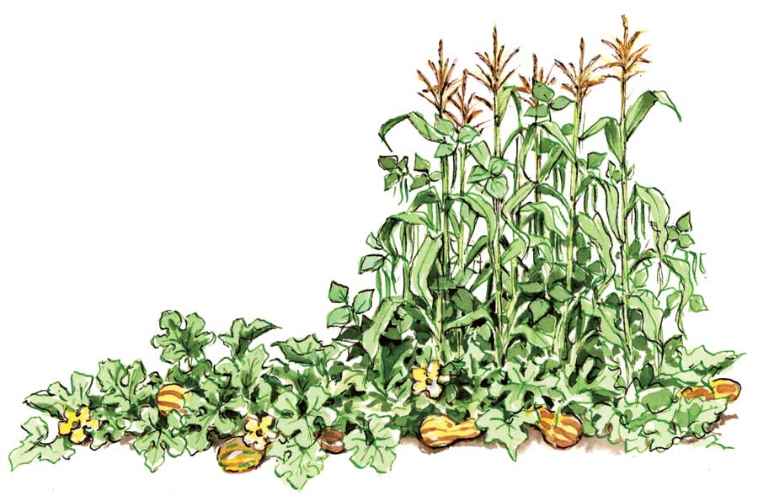maintenance of the crops is less necessary.

Illustration of Wampanoag Three Sisters Garden from Scherrer, Emy. “Understanding the Historic Wampanoag Three Sisters Garden.” *Garden City Harvest*, Garden City Harvest, https://www.gardencityharvest.org/the-real-dirt-garden-city-harvest-blog/2016/03/30/understanding-the-historic-wampanoag-three-sisters-garden-a-short-lesson-in-folklore-and-planting.

Planting Three Sisters: All three plants are warm-season plants that should be planted in the spring after the season’s last frost. Form low hills spaced three to four feet apart and planted five to seven corn seeds at a depth of 1 to 1.5 inches. When the corn plants are about six inches high, plant four to five pole bean seeds around the corn plants in every hill. Squash grows vines, so it is essential to balance the squash in each hill to prevent the garden from becoming overwhelmed with vine growth. Plant squash seeds around the perimeter of a few hills, depending on how many hills are in each planting bed. Pumpkins can be used in place of squash, with the same rules applied. In the first year, the planting site will need to be fertilized, as the nitrogen from the beans will not be available until after the first harvest—once the bean roots have started to break down. Water the plants once a week. Corn is ready to harvest three weeks after the tassel grows on the top of the plant. Squash is ready when fruit and seeds are small. Beans are ready one to two weeks after flowering when the pods are firm and smooth.

Okra is another good option for summer. It takes up less space than other plants, thrives in the North Texas climate, is fairly disease resistant, and can be prepared and served in various ways. Okra should be planted in spring, 2 to 3 weeks after the season’s last frost. Plant seeds 1 inch deep and 2 inches apart, in rows spaced 3 feet apart. When the plants are up, thin them out to 1 foot apart. Okra thrives in 80-to-90-degree weather, either dry or humid, perfect for early summer in North Texas. Water the plants every 7 to 10 days. The plants will produce large flowers about two months after planting, and then the pods will be ready to harvest 3 to 4 days later. Continue harvesting every 1 to 2 days as long as the plant produces pods. Okra can be stored in the refrigerator for 3 to 5 days, then dried and cured.

Fall:

When it comes to garden planting in Texas, it is important to consider the Hardiness zone and Texas Gardening zone we are in. The University of Texas at Arlington is currently in the Texas Gardening Zone three, also known as Hardiness zone eight (average soil temperature 10-20 degrees Fahrenheit).

Before considering which fall season crops to plant in the gardens of the University of Texas, it will be important to make sure the soil is ready for the fall-specific plants in the gardens. The plant residue from the spring season soil should not be used in the compost to grow the fall plants. This is to prevent any plant disease and insects that would harm the incoming plants. Furthermore, when it comes to planting for the fall season, in particular, it is important to start the crop by transplanting, rather than the seed. In order to have a successful crop during the fall season it is necessary to prepare in advance during the summer season. Transplants, rather than plain seed, is best recommended to be used for healthier plant outcome. More specifically, transplants should always be used for tomatoes and peppers. The key to success in fall planting and gardening is harvesting the product according to the correct season and type of plant.

There are many plants that thrive during the fall season. One subset of plants that are successful during the fall season are herbs. Herbs are versatile, they can be annuals (live for only one season) and perennials (grow back from root seasons every year). Overall, herbs would be taken care of in the same way vegetables or flowers for the fall season would be taken care of. A few potential herbs that would thrive in the Arlington area during the fall season are Basil, Catnip, Rosemary, Mints, and Sage. Some herbs can be grown straight from the seed in the garden or can be grown indoors then be transplanted to the garden site. It is recommended to buy the seed from a local small farm or save the seeds for the next year’s crop. Planting at the proper time is the most important factor in successful fall gardening.

On the other hand, there are also vegetables that can be grown during the fall season. Ranging from Broccoli to Carrot. To list a few more vegetables that are suitable for planting during the fall season in the University of Texas at Arlington, there are beans, cauliflower, cucumber, peppers, squash, and spinach. All of these vegetables have specific types of needs and differences that need to be considered when planting, but they are well suited for the Texas soil and climate.

Winter:

While the options for gardening are more limited in the winter season, there are a variety of plants and vegetables that can withstand the harsh temperament of this season. In order to bring more edible vegetation to the UTA campus, one must first examine what vegetables can withstand the winter season. Luckily, there are a variety of vegetables that can tolerate harsh weather conditions, such as broccoli, carrots, kale, cabbage, turnips, and fava beans.

Broccoli thrives in cooler weather and can survive in temperatures as low as 25 degrees Fahrenheit. While broccoli does require full sunlight and fertile, rich soil to grow, it is frost-tolerant and has a clear visible indication of when it should be harvested (right before it starts to flower). Carrots are another popular vegetable that is also appropriate for winter gardening. Carrots can survive in soil temperatures around 40 degrees Fahrenheit and can be grown in fun or partial shade. While carrots can survive a light frost, they must be harvested before the ground freezes and stored in a cool, moist environment. However, the root of a carrot will survive a freeze, so even if they are not harvested in time, some of the carrots can be salvaged.

Both kale and cabbage are exceptional vegetables to plant in the winter because they can survive in negative temperatures and flourish throughout winter. Furthermore, the best time to harvest these vegetables is after a frost because it makes them more flavorful. However, kale will not last long after being harvested, so it should only be pulled when it will soon be used. Alternatively, cabbage can be stored in a cool environment for several months after it is harvested.

Turnips will germinate in low temperatures and can be planted in the sun or partial shade. While hard freezes can damage the vegetable’s flavor, a light freeze will improve it. The leaves and roots of the turnip can be harvested and stored in a cool, dry area for several weeks.

Fava beans are another frost-tolerant vegetable that can withstand the low temperatures of winter. Fava beans are relatively easy to plant, requiring full sun and only needing to be watered prior to the soil drying out. Fava beans can be harvested after about 85 days (about three months) and will last about a week in the fridge and longer if they are frozen or dried.

Furthermore, the temperament of the winter season can cause significant damage to the soil, depleting the nutrients and making it less desirable for gardening. Therefore, cover crops are a crucial component for gardening in the wintertime. Cover crops are plants grown over the winter season to provide protection and enrichment to the soil that would otherwise lay bare to the cold environment during winter. Luckily, most cover crops are edible and are often used as spices. Since the soil in Arlington is mainly alkaline soil, the best cover crops to plant would be ones with deep or fibrous roots to break the solid up and incorporate the nutrients. Mustard is an excellent cover crop for this type of soil because it can be sown prior to winter to help replenish the soil over the winter season. Furthermore, mustard has a high amount of glycosylates, which reduces the number of pesticides needed.

In addition to vegetables and cover crops, there are also a variety of plants that will make the garden aesthetically pleasing and thrive in the winter. Scilla is an exceptionally durable plant that thrives during the winter and is low maintenance. Scillas can be planted in partially to fully shaded areas. Winter Pansies are another excellent plant for winter gardening as they bloom in various colors and will start blooming as early as December. Additionally, Winter Pansies can be grown in full sun to full shade. The Algerian Iris would be another great addition to the garden because of the vibrant color and sweet scent throughout the winter. While this plant does require full sunlight to grow, it will start blooming as early as November. In addition to these plants, there are a variety of other plants such as Crocus, Ranunculus, Japanese Camellias, and Kaffir Lilies that can withstand the harsh temperatures of winter while also bringing color to the garden.

When gardening in the winter, there are various methods one can use to protect existing plants. Applying generous amounts of mulch or straw to planting beds will help protect the soil from pelting rains and hail while simultaneously insulating the soil temperatures. A floating row cover is a specifically designed fabric to protect plants against frost. It will protect plants from cold snaps and low temperatures by insulating the soil. Lastly, plants can be planted on straw bales for added warmth during the colder seasons, as straw bales continuously decompose, which therefore continuously generates heat.

Additional Plants

With these seasonal edible plants in consideration, we can also consider the growth of non-edible plants alongside and in between for fundraising and garden protection purposes. Catnip, or *Nepeta cataria*, would be a great fundraising plant because of its popularity with cats and cat owners. Additionally, UTA has a massive nonprofit club dedicated to the care of over 100 feral cats that live on and around campus. This gardening program could efficiently work with the Campus Cat Coalition (CCC) to raise funds for future garden activities and plant upkeep. The CCC has been very eager to work with our potential project and organization, especially regarding the catnip and volunteer opportunities.

Thankfully, successfully growing catnip is not a difficult task and once grown is a perennial plant. Catnip could be grown either inside or outside, and we would work with the CCC regarding outdoor planting locations or if we should keep growing the catnip indoors. If they were to be planted outdoors, it is recommended to plant them in a location safe for cats to frequent and behind more attractive flowers for garden appearance purposes (“Texas Herb Gardening – Catnip”). Catnip requires some light watering, but nothing excessive. Additionally, these plants do better with morning sun and afternoon shade during the hot Texas summers. There are many grow-your-own catnip kits available in garden stores and online that, on average, range from 5 to 10 dollars. Due to being part of the mint family, catnip can spread and self-seed. If regularly managed in a garden bed or kept indoors in pots, this would not be a significant issue and would rather work in our favor.

           Butterfly plants would be another way to attract students and faculty to our gardens while also adding to the aesthetic. There are a variety of butterflies that have each favored nectar and host plants. Nectar plants are necessary for adult butterflies, and host plants provide a place for butterflies to lay eggs and leaves for the caterpillars to eat. Both are necessary to attract butterflies. Since UTA is in the north Texas region, pandering towards the monarch, queen, and fritillary butterflies would likely be the most effective and sustainable. This is because the plants required for these specific butterflies overlap and are accustomed to the local weather. The three plants our butterfly garden could start with are butterfly weed (Asclepias tuberosa) (see fig.15), mistflower (Conoclinium greggii) (see fig.16), and violets (Viola) (see fig.17).

|  |  |  |
| --- | --- | --- |
| Consortium of Intermountain Herbaria - Asclepias tuberosa | Blue mistflower is a fall-blooming perennial that offers color year-round | Violet - Flowers - Featured Content - Lovingly |
| Fig.15. Picture of Asclepius *t*uberosa from “Asclepius Tuberosa.” *Consortium of Intermountain Herbaria*, <https://intermountainbiota.org/portal/taxa/index.php?taxon=3789&clid=4230>. | Fig. 16. Picture of *Conoclinium greggii* from “Plant Primer: Blue Mistflower Offers Color throughout the Seasons.” *The Columbus Dispatch*, The Columbus Dispatch, 19 Sept. 2021, <https://www.dispatch.com/story/lifestyle/2021/09/19/blue-mistflower-fall-blooming-perennial-offers-color-year-round/8310319002/>. | Fig.17. Picture of violets from “Violet.” *Lovingly*, 20 Aug. 2021, <https://www.lovingly.com/featured-content/flower-meanings/violet/>. |

Butterfly weed would act as a host plant for monarch butterflies and host and nectar plants for queen butterflies. Since butterfly weed is a milkweed plant favored by many types of butterflies, expanding the garden would take adding just a few specific host plants to attract significantly more butterflies. Butterfly weed thrives in many soils and is a low-maintenance plant. When this plant grows back, it is more plentiful in blooms as it is a perennial. This plant does well in full sunlight but is resilient enough for some hours in the shade (Vanderlinden). Once butterfly weed is established and mature, this plant prefers dry soil. Butterfly weed’s blooms are a bright orange bunch that matches UTA’s accent school color. Due to this plant’s high nectar content, it can also attract other pollinators such as bees and hummingbirds.

The mistflower is a nectar flower for the monarch, queen, and fritillary butterflies. These flowers are a light purple and are similarly low maintenance like the butterfly weed. Mistflower can bloom in many types of soil, requires low amounts of water, and is a sturdy plant overall. Furthermore, they are a perennial plant that grows to about 1 to 2 feet high and spreads if left to their own devices. The seeds for these plants are easy to come by, as is true for butterfly weeds.

The last of the three are violets. Violets are a host plant for fritillary and add a bright pop of color to the floor level of the garden. These plants are slightly more demanding for water and soil maintenance but can easily be placed in a small separate bed or group of pots. Violets enjoy moist and well-drained soil as well as time in the shade. Violets favor cooler weather and naturally bloom late winter or early spring (Welch). These vibrant and fragrant flowers are perennial but can be considered annuals or biennials.

Thankfully with butterfly gardens, there are no required certifications to start. However, to show our dedication towards the butterflies, we can apply for the North American Butterfly Association (NABA) Butterfly Garden Certification program. The garden would only be a few steps away from meeting the NABA’s requirements with the three butterfly-targeted plants previously mentioned. This could also act as one of the many goals of the garden that could motivate student activity and work as a tangible achievement. Once certification is achieved, signs can be purchased alongside the certification to be posted around the garden.

Lastly, in honor of our professor, we would like to plant apple trees. We had initially envisioned planting one large apple tree on campus, but we have discovered an enticing alternative. Columnar apple trees would take up significantly less space and faster production time. Columnar apple trees have been developed to produce apples practically right off the trunk. With their short branches, columnar apple trees can grow 8 to 10 feet tall while remaining less than 2 feet in diameter (Gregory). Ideally, we would have 2 or 3 columnar apple trees for cross-pollination. In full sun within the first year, fruit can already be expected (Gregory).

In contrast, standard apple trees can take many years before the fruit is produced. These compact trees can be planted into the ground or cared for in large containers. A variety of apple trees have been bred to the columnar standard and allows flexibility for the growth of apples the gardening community would be interested in. These would likely be the costliest of the other plants but add a significant wow factor to the garden in addition to the iconic apple staple of the education system.

Fig.18. Picture of columnar apple tree from “Columnar Apple Tree Care.” *Watson's Greenhouse*, Watson's Greenhouse, 25 Jan. 2021, <https://shop.watsonsgreenhouse.com/blogs/news/columnar-apple-tree-care>.

Cost Analysis

As mentioned in the fall crops section, growing plants from live transplants rather than seeds is the recommended method in Texas. It is difficult to purchase live transplants, especially in the volumes necessary for a garden of this size. As such, it would be necessary to either grow transplants ourselves indoors from seeds—a labor-intensive process prone to failure—or plant seeds instead of transplants. Seeds, while less successful when directly planted, are more cost effective and easier to source. Seeds for most plants discussed in this section can be purchased in packets for 5 to 10 dollars. These packets can be bought online or from local nurseries and small farms. For better success when planting seeds, it is recommended to plant multiple seeds at a time and thin the plants out once they come up.

Soil

The city of Arlington lies within Tarrant County of Texas, which has a mix of clay, sand, loam, and silt soil types (Soil Alive). Arlington is in a special part of north Texas where three geographic areas, the Blackland Prairie, the Eastern Cross Timbers, and the Grand Prairie, all blends. The University of Texas at Arlington is on the border between the Eastern Cross Timbers, which is home to sandy loam soil, and the Grand Prairie, which is home to a mix of limestone, silty loam soils, and clays. These soil types are very alkaline, meaning that plants have a harder time taking nutrients from the soil, which ends up limiting their growth. When picking plants, it would be important to choose specimens that are more tolerable to alkaline soils.

Some of the plants that grow well in alkaline soil are asparagus, beets, okra and cabbage. Moreover, in order to make sure that other species of plants can be grown on-campus we would need to treat the alkaline soil to make it suitable for other plants. This can be done by mixing the sulfur to the compost and then adding it to the soil. There are three different types of sulfur: common sulfur, ferrous sulfate and aluminum sulfate. Common sulfur is the least expensive option if we’re looking to reduce costs. Ferrous sulfate works best with plants that have yellowing leaves and have a poor health. Aluminum sulfate is the most effective one since it reacts quickly, although it will be required to use in larger quantities for a noticeable change.

Fertilizers

With regards to the nutrients the plants are receiving, we’ll need to start using fertilizers to ensure that the plants do not wither. The fertilizers can be inorganic or organic depending on availability and the cost. Inorganic fertilizers consist of Nitrogen, Phosphorus, and Potassium in varying contents depending on the nutrient lacking in the plant. These fertilizers are not made from natural materials, and these emerge from chemical processes. Nitrogen fertilizers are used during the middle stage of a plant’s growth are helpful in encouraging it grow larger and grow new leaves. Phosphorus fertilizer is used to strengthen the root system and the stems of a plant. Phosphorous is vital mineral for the flowering, seeding, and fruiting of the plant. A lack of phosphorus stunts the plant’s growth. To ensure that the plant grows properly, fertilizer have to be used before planting the seeds. Potassium helps the plant develop deeper and stronger roots. It also helps protect plants from harm when deprived of other nutrients. This nutrient is essential for photosynthesis and can delay diseases that can affect the garden.

Organic fertilizers consist of manure, compost or other animal and plant products. It may be more cost effective to create our own bio-compost of plant waste. However, if the plants do not thrive well with organic fertilizer, we may have to switch to inorganic fertilizers to ensure our harvest isn’t in poor health.

Equipment

When it comes to gardening equipment, the equipment needed varies on the size of the garden. Starting out, the essential tools needed are hand trowel, hand cultivator, garden fork, garden shovel or spade and garden rake. A hand trowel will be beneficial in digging small holes to plants the seeds and measuring depths in the soil. A hand cultivator is like a fork with three tines and is used to remove weeds and rough up the soil. A garden fork will be useful in turning over the soil and compost and digging out root crops. A key tool for gardening is the spade, which is essential for moving soil. And the straight-edged flat blade is helpful in cutting roots, removing weeds, and making edgings. A garden rake would be valuable in smoothing the soil and removing the garden of debris and small rocks.

Hand pruners and garden scissors are crucial for pruning, deadheading, and harvesting. A hand pruner is versatile when it comes to trimming small branches, perennial plants, shrubs, or trees. Hand pruners can also be used to harvest ripe vegetables without damaging the plant. Garden scissors are extremely useful when it comes to deadheading, which is the removal of dead flowers, snipping herbs and flower stems, and pruning delicate plants.

Weather and Pest Damage Prevention

There are many factors to consider when starting a garden, one of those being weather conditions. Each season brings different types of weather, and throughout these conditions, there are certain things a plant needs; it can be significant such as not planting at all for a few weeks or minor such as only watering at certain times of the day. To further understand what work would be needed, we researched and interviewed Dr. Jason Hogue, an English professor at UTA who volunteers his time at a garden.

Dr. Hogue has had a plot in the garden for about 5 or 6 years and uses it for organic gardening and to teach his students about sustainability and how to garden overall. Depending on the season, he will grow either food or flowers but usually lets his students decide. When asked how Dr. Hogue cares for plants in the summer, he says that he will only go out when there is cooler weather and will only plant plants that thrive in the summer, such as melons. We also asked him how he cares for plants during the winter; he says he tries not to grow anything when the weather is too cold. Dr. Hogue prefers only to grow plants during the growing seasons, and when the weather conditions become extreme, he leaves the plot alone and waits until the weather gets better to continue gardening.

While we did learn a lot from Dr. Hogue, we also researched the different weather conditions and how to be prepared for each one. One type of weather condition is thunderstorms/heavy rains. During thunderstorms/heavy rains, plants run the risk of enduring too much water and can be damaged by the strong winds a thunderstorm could bring. According to American Native Plants, there are a few ways to protect plants from this type of weather: protecting the roots, coverage, and anchors. To protect the roots of a plant, a 3-inch layer of mulch would help (American Native Plants). Covering plants with appropriately sized containers also helps plants from suffering from wind and rain damage. It is good to use stakes tied to the stem to keep the plant from bending too far, causing damage for any plants above ground. These are all ways that we could consider when working with thunderstorms/heavy rains.

Another weather condition that should be taken into consideration is the heat. In Texas, we deal with many heat waves, and most of the time, it is generally hot. We have learned that some plants thrive in the heat, and others, unfortunately, do not. Fortunately for us, Deanna from Homestead and Chill work on an article about preventative measures for heat. As mentioned before, mulch is a big help and can help even during a heatwave. One important thing to do is water the plants deeply and make sure there is a routine. Doing so will help the roots grow longer and more robust and keep the soil moist and cool. (Deanna) Something to avoid during a heatwave is wetting the plant leaves. The water droplets can magnify the amount of heat hitting the plant, causing damage. Lastly, having shade over the plants is a big help. The shade keeps the plants cool but still allows some sunlight to reach the plant and airflow.

To cover the last topic of weather, it is crucial to mention frost. Lately, it has been cold to the point of freezing during the winter season, so we must take preventative measures when working with the garden during those times. First and foremost, it is essential to know the estimated frost dates to begin preparing. The primary way to protect plants from frosts, according to The Old Farmer’s Almanac, is to cover them with a blanket or row cover. Plants can also be protected by being watered well before the frost, and once again, mulch helps. There are also cold frames, essentially a homemade cover that keeps the plants well insulated and protected from the cold. The frames could be either portable or permanent.

Every garden also has its fair share of pests, some good and some bad. Although, when gardening, any unwanted pets must be taken care of. When dealing with edible plants, using natural ways of keeping pests out is vital. It would not be safe to use pesticides on something that may be eaten in the future. Fortunately, there are a few ways to keep pests out of gardens naturally. According to an article written by Ebony Porter, there are five ways to keep pests out. Crop rotation, Spiders, Catnip, Ladybugs, and planting Parsley, Dill, and Cilantro (Porter). Crop rotation helps with misguiding pests; the plant that was their food one year would no longer be there for the next, leaving them with no food. Spiders eat all sorts of insects which can be helpful since they will not harm the plant. Catnip helps keep stinkbugs away and can be used all over the plant beds. Ladybugs is another animal that is harmless to plants but can keep unwanted pests away and can eat up to 50-60 aphids a day, but it is not the only thing they eat. Planting extra parsley, dill, and cilantro attracts the right type of pests to get rid of the unwanted pests and therefore keep the garden healthy.

UTA is not a campus unfamiliar to squirrels. Therefore, we must find ways to keep both the plants and the squirrels safe. One way to keep squirrels away is to place a thin layer of coffee grounds in the plant bed or by planting mint, marigolds, nasturtiums, or mustard since they do not enjoy the smell (Hagen). Another way is to give them their feeding ground, which could attract more squirrels and keep them away from the garden.

The prevention of different weather conditions and pests will also be necessary whether we are working on the upkeep of old gardens or creating new ones. Unexpected weather conditions are unavoidable, and hungry little critters are looking for food, so to combat this, we present you without plans to prevent such things.

According to Gardeners, a gardening website, there are three steps to keeping pests out of your garden (Gardeners):

1. Identifying the issue, anything from finding dug-up plants to chewed up leaves when checking up on your garden, the identification of the problem comes first.
2. Prevention measures, coming up with solutions to the problems that you identified.
3. Keeping those measures in place for the future to make sure that these problems do not reoccur.

While we can keep these in mind while planning the garden, we cannot fix a problem until it occurs. We aim to be proactive in preventing pests rather than reactive. That being said, the observation and monitoring of the garden will be vital in preventing pests and adjusting for weather.

One of the best ways to prevent pests in a garden is to know what animals you have in the area and take measures for those animals specifically. It is well known that UTA has a large squirrel population on campus. A student could spot upward of 8 squirrels roaming in Brazos Park alone on the way back from class. One way to prevent little critters from disturbing the gardens is, planting plants that the animals do not like. Squirrels do not like many types of flowers, but to specify, daffodils (*Florgeous*). Including these types of plants in the garden will deter such animals in a basic and effortless way, along with planting specific plants to deter animals, such as hot peppers or any plant containing capsaicin. This type of prevention is natural, and the only drawback is the invasiveness of such plants, which could be easily prevented with correct housing and managing the garden. There are also some types of animals that you would want to attract to a garden, such as bees. They are natural pollinators and will help with the development and health of the garden. They are attracted to many types of herbs and flowers, so the inclusion of these plants will not only be for aesthetic purposes but management as well (JPPestServices).

On the topic of correct housing and managing of a garden, fencing is necessary for protection, housing, and aesthetic purposes. When deciding to fence, there are many considerations considering the size and accessibility of the garden, pests’ prevention when determining height, and aesthetic purposes (Gardeners). Considering the size and accessibility that we plan on for the garden, the original consideration for fencing was either a wooden fence or some mesh fencing. Wood looks more professional than a mesh fence for a college garden. A wood fence would work well to keep people out of the garden, but not many squirrels. This was when the option of glass fencing presented itself. Glass fencing is not only aesthetically pleasing for viewing the environment unobstructed but also for the prevention of animals in the garden. This would also play well with the newer UTA look with the SEIR building and the new additions to the campus.

With all of that said, animals are not the only thing we have to look out for prevention in the garden. Weather plays a huge factor in the wellbeing of the place and the maintenance of overall garden health. To have a healthy garden, there must be mild weather and care. The weather is unpredictable, but we are going for a proactive stance, not reactive. This means working around weather conditions for the benefit of the garden. There are multiple solutions for this, from a seasonal garden to student care and maintenance specifics. A seasonal garden would make the most sense given the structure of the school year of UTA as two semesters with about a month for winter break and even more for summer. Maintaining a full garden full-time might not be manageable, and we might not have the staff willing to do so, and the protection of plants is dependent on human care much of the time (Bobvila). Seasonal gardens would have less work to maintain but more work to plan. This lends itself to the UTA Gardening Club, a club that plans what plants will be planted and works to maintain the garden overall. A seasonal garden would require one day to plant and minimum maintenance before the semester begins and then care during the semester versus a full-time, year-round garden. There are also ways to prevent heat and other weather conditions while waiting for the fall semester to start, like adding more mulch to the garden to keep the soil cool underneath (Eartheasy).

Fundraising Opportunities

As previously stated, designing, clearing land, and building a garden would be a costly endeavor; however, these upstart costs could be alleviated through fundraising. In constructing the garden, there could be an auction to put bidders’ names on the brick pavers or wooden boards making up the raised planter boxes. Similar to the named stone pavers outside of the Honors College, this could be one way to fundraise for the garden. Putting plaques on benches scattered around the garden, naming them after people who have contributed to the university or the garden itself, could be another way to fundraise.

The garden’s plants could be sold to students with the cost of said items being redistributed to the garden. Pricing of these items would be based upon the cost of purchasing the original plants and then wanting to turn a profit on the sale. These profits would then be given to the appropriate university maintenance crew to help cover the cost of the garden.

Additionally, the garden having seasonal plants and growing seasons could allow for seasonal events, such as a fall harvest event or a spring replanting event. During the harvest event, the garden could host a fall festival with the help of other organizations. Students and residents of Arlington could purchase tickets to attend booths and be offered the chance to buy the harvest from the garden. The spring replanting event could have students pay a small fee to name a plant or a specific section of the raised planting boxes. These two events could allow volunteers from various on-campus organizations to obtain service hours and leadership experience. Volunteers could collect and handle the money until the end of the event, where the money would then be passed off to the university service dealing with maintaining campus grounds.

**Benefits of the Garden**

Social Benefits

The potential social benefits of implementing a community garden on the UTA campus could be described as both innumerable and impressive. The most prominent of said benefits consists of providing a space for members of the UTA community to interact and grow together. Not only would the physical space itself create the opportunity to promote the interaction and growth of the community, but the act of growing and caring for the garden would as well. The increased group physical activity would improve both the physical and mental health of the community and the social connection between those in the community. The general act of gardening would open those within the community to opportunities to partake in experiential learning, relationship-building, and growth regarding mental and spatial awareness, all while improving the environment in turn.

Volunteer Opportunities

Many students could be exposed to easily accessible locations to volunteer through the gardens. With one of the five Maverick Advantage pillars being service, many students engage in regular service opportunities during the year. By introducing a well-known and accessible garden, students could volunteer hours serving fellow students. During our public opinion poll, 64.3% of students said that they would be willing to volunteer at the garden. While this poll was conducted on a smaller scale and attempts to represent the student body, there is significant evidence that students would be willing to volunteer their time to the garden. Not only could this provide service opportunities to students pursuing the Maverick Advantage, but this could also provide opportunities for local groups outside of campus to gain volunteer hours. Local chapters of the National Honor Society and National Junior Honor Society, various scouting groups, and various religious organizations could use the gardens as service opportunities. This would mean that the garden is well maintained and enjoyed. Additionally, opening the garden up to students and people outside of the university could encourage more students to attend UTA because of its service-minded attitude.

Seasonal Benefits

The seasonal benefits are yet another category of improvement that would come about from implementing a community garden on campus, most prominently regarding mental health. Seasonal depression is, according to the Mayo Clinic, a widespread issue in the United States, with upwards of three million cases per year, especially among those fourteen years of age and older (Mayo Clinic). Seasonal affective disorder (seasonal depression) most prominently affects those afflicted during the winter, which may cause one to wonder how a garden could improve or positively affect those suffering from said disorder given the growing or active season of a public garden. However, we intend to alleviate the mental strain on those in our community year-round. Whether it be via the implementation of plants that, against the odds, flourish in the cold months of the year or merely via the events we intend on producing that would brighten the spirits of those in our community during said dark months, a community garden on campus would undoubtedly harbor benefits year-round.

**Concerns**

A community garden will have many benefits, such as easy access to nutritious fruits and vegetables and an increased sense of community. Though, every garden has its downsides. Some could say that a community garden is more of a burden. As a normal part of all gardens, it is bound to attract many potential pests, ranging from several species of insects to species of rodents. Furthermore, creating a community garden will take a reasonable amount of time and effort to establish successfully. Moreover, along with effort, there will be the hardship of recognizing the differences between each type of plant. However, not all of these are entirely negative, with no way of avoiding them.

Regarding the potential pests that may end up living or eating from the potential garden, it can be implied that it is an issue that will resolve itself over time. We are currently trying to establish a connection with the Campus Cat Coalition (CCC) in our plan. We will be obtaining more information about cats and how to appeal to them with the gardens, such as adding cat food and catnip around the potential garden. With the cats around, it can be implied that the number of rodents around the garden will be significantly lower than without. However, after speaking with the president from our CCC program, we learned that catnip rarely appeals to cats, and only a small selection will be appealed by it. We also learned where cats primarily roam around lie in the east portion of campus, near the university center, and lot 50. With this information, we can be aware of how much catnip would be needed depending on the location of the gardens and reduce the number of pests such as rodents with the abundance of cats. Until catnip is ready to be picked, some cover or glass container would help keep rodents out. We also came to learn that simply by the smell cats leave behind, rodents smell this and become afraid and therefore avoid the areas. Cats also emit a sort of chemical that deters mice away from your gardens and home. There is also another solution which is using natural repellents such as garlic clips and castor oil which are effective in discouraging rodents from coming near the area. If this does not seem to be the best option, there are also devices such as water sprayers and reflective tape which also help when keeping rodents out. In addition, there will be fewer pests and rodents to worry about dealing with (Lupo). However, cats are especially good at catching rodents and repelling them with their scent so alternatives may not even have to be used. For the pests that remain, several affordable types of pesticides may be used that will not affect the overall quality of the garden.

Furthermore, regarding the amount of time, effort, and funding to fully establish the garden, we have seen from our polls that we have a relatively large amount of support. From said results, it should not be challenging to receive volunteers or donations to help the idea of making a potential community garden a reality. Not only that but as stated earlier, growing a community garden provides many social benefits, such as growing deeper connections amongst peers (DeMuro). Furthermore, we plan to raise various fruits and vegetables in the garden. Each will have its growth requirements, such as temperature, soil types, and water patterns. There is currently a group designated for studying the different growth requirements for all potential fruits or vegetables that we are planning on growing in the garden to combat this issue. After the said group has finished its research, we will be able to provide the correct soil types or nutritional supplements to ensure all plants will successfully grow and prosper.

While having an on-campus garden has its benefits, alternative solutions also provide cost-effective methods to bring fresh produce and groceries to UTA. There is currently a 2850 sq ft (about the area of a tennis court) produce and grocery store, Ann’s Health Food Center & Market, being developed in downtown Arlington next to the UTA campus in the 101 Center district. This would be in 500 ft proximity to about 796 students living in campus housing.

As brought up by Dr. Rebekah Chojnacki, the College Park district also hosts three adjacent available leasing spaces totaling 6660 sq ft (about twice the area of a tennis court) combined as of December 2021. This area could be repurposed into a grocery store to help generate revenue and traffic into the newly developed district. With three campus student residency buildings in proximity, there should be adequate food traffic to make a business sustainable. A grocery store on campus would complement the multiple campus convenience stores found throughout UTA.

**Conclusion**

After reflecting upon the University of Texas at Arlington’s fresh food desert crisis, we conducted research to address the benefits and concerns of developing a campus garden. Through interviews with campus organizations and staff and public opinion polls, we were able to highlight the importance of creating an on-campus garden. Of the staff interviewed, many were very interested in the idea of a garden being built on-campus and the impacts it would have on the student body. Likewise, students also expressed interest in the gardens in regard to fresh produce and as a study space. Additionally, the majority of students in the polls showed interest in volunteering at the gardens. This garden and green space, while creating produce and volunteer opportunities, serves as a space to gather the UTA community. Having a garden on our campus will bring endless benefits not only for our physical health, but our mental health as well. In the end, this will satisfy our primary goal, providing fresh produce to the UTA students and faculty.

**Works Cited**

Account, Admin. “The Ultimate Guide to Seasonal Gardening.” *Garden Goods Direct*, Garden Goods Direct, 8 Oct. 2021, <https://www.gardengoodsdirect.com/blogs/news/ultimate-guide-to-seasonal-gardening>.

“Asclepius Tuberosa.” *Consortium of Intermountain Herbaria*, <https://intermountainbiota.org/portal/taxa/index.php?taxon=3789&clid=4230>.

“The Benefits of Bees to Your Garden (When Well-Controlled).” *JP Pest Services*, 24 Aug. 2018, [www.jppestservices.com/blog/the-benefits-of-bees-to-your-garden-when-well-controlled](http://www.jppestservices.com/blog/the-benefits-of-bees-to-your-garden-when-well-controlled).

BobVila.com. “10 Ways to Weather-Proof Your Garden.” *Bob Vila*, Bobvila.com, 31 Mar. 2017, www.bobvila.com/slideshow/10-ways-to-weather-proof-your-garden-50980.

“Butterfly Garden Certification Program.” *North American Butterfly Association*, 1 July 2019, <https://www.nababutterfly.com/butterfly-garden-certification-program/>.

“Butterfly Gardening Guide.” *Texas Discovery Gardens*, <https://www.txdg.org/butterfly-garden>.

“The Carbon Cycle.” *NASA*, NASA, 16 June 2011, <https://earthobservatory.nasa.gov/features/CarbonCycle/page5.php>.

ClientEarth Communications. “What Is a Carbon Sink?” *ClientEarth*, 22 Dec. 2020, <https://www.clientearth.org/latest/latest-updates/stories/what-is-a-carbon-sink/>.

“College Park District at the University of Texas at Arlington.” *Parking - College Park District - The University of Texas at Arlington*, <https://www.uta.edu/collegeparkdistrict/parking/index.php>.

Collins, Nancy. “Enticing North Texas Butterflies to Your Yard.” *Texas Master Naturalist - Elm Fork Chapter*, 2021, <https://www.txmn.org/elmfork/enticing-north-texas-butterflies/>.

The Columbus Dispatch. “Plant Primer: Blue Mistflower Offers Color throughout the Seasons.” *The Columbus Dispatch*, The Columbus Dispatch, 19 Sept. 2021, <https://www.dispatch.com/story/lifestyle/2021/09/19/blue-mistflower-fall-blooming-perennial-offers-color-year-round/8310319002/>.

“Crops Guides - Small Acreage Horticultural Crops Small Acreage Horticultural Crops.” *Aggie Horticulture®*, <https://aggie-horticulture.tamu.edu/smallacreage/crops-guides/>.

Curell, Christina. “Mustard as a Cover Crop.” *MSU Extension*, 29 July 2021, <https://www.canr.msu.edu/news/mustard_as_a_cover_crop>.

DeannaCat. “6 Ways to Protect Garden Plants in a Heat Wave ~ Homestead and Chill.” *Homestead and Chill*, 16 June 2021, <https://homesteadandchill.com/protect-garden-heat-wave/>.

DeMuro, Katie. “The Many Benefits of Community Gardens.” *Greenleaf Communities*, 30 Apr. 2021, <https://greenleafcommunities.org/the-many-benefits-of-community-gardens/>.

“Double Occupancy Suites.” *The Shorthorn*, 23 Mar. 2021, <https://www.theshorthorn.com/housing/properties/double-occupancy-suites/article_8c8ce7e4-8bec-11eb-9e56-ab716aab7efa.html>.

Everhart, Eldon. “How to Change Your Soil's Ph.” *How To Change Your Soil's PH | Horticulture and Home Pest News*, 6 Apr. 1994, <https://hortnews.extension.iastate.edu/1994/4-6-1994/ph.html>.

“5 Ways to Protect Plants from Thunderstorms and Heavy Rain.” *American Native Plants*, 14 Sept. 2018, <https://www.americannativeplants.com/5-ways-to-protect-plants-from-thunderstorms-and-heavy-rain/>.

“4 Different Types and Forms of Fertilizers.” *All Green Pest Control and Lawn Care*, <https://www.myallgreen.com/the-different-types-of-fertilizers/>.

Garcia, Zuri. “Gardening and Mental Health.” *UtahStateUniversity*, 12 Apr. 2021, <https://extension.usu.edu/aware/articles/gardening-and-mental-health>.

“Garden Fencing to Keep Animals out: Gardener's Supply.” *Www.gardeners.com*, www.gardeners.com/how-to/keeping-animals-out/5452.html.

“Gardening & Landscaping Publications - Texas A&M AgriLife Extension.” *Texas A&M AgriLife Extension Service*, 13 Nov. 2019, <https://agrilifeextension.tamu.edu/library/gardening/>.

GivePulse. “UT Concho Community Garden: The University of Texas at Austin.” *GivePulse*, 2021, <https://utexas.givepulse.com/group/353-UT-Concho-Community-Garden>.

Gregory, Elliot. “Columnar Apple Tree Care.” *Watson's Greenhouse*, Watson's Greenhouse, 25 Jan. 2021, <https://shop.watsonsgreenhouse.com/blogs/news/columnar-apple-tree-care>.

“Growing Guides.” *Almanac*, Yankee Publishing Inc., <https://www.cabi.org/wp-content/uploads/List_of-fulltext-material-from-conferences-miscellaneous-items-by-subject-October-2021.xlsx.>

Hagen, Linda. “How to Keep Squirrels out of Your Garden - Garden Design.” *GardenDesign.com*, Garden Design Magazine, 8 Oct. 2021, <https://www.gardendesign.com/how-to/squirrels.html>.

Hayes, Bethany. “How to Fix Alkaline Soil in the Garden.” *MorningChores*, 18 Feb. 2021, <https://morningchores.com/alkaline-soil/>.

“How to Plant the Three Sisters.” *Cornell Garden-Based Learning*, <https://gardening.cals.cornell.edu/lessons/curricula/the-three-sisters-exploring-an-iroquois-garden/how-to-plant-the-three-sisters/>.

“How to Protect Your Garden during a Heat Wave.” *Eartheasy Guides & Articles*, <https://learn.eartheasy.com/articles/how-to-protect-your-garden-during-a-heat-wave/>.

Kilbride, Benjamin. “What Gardening Tools Do You Need?” *Almanac.com*, 12 Nov. 2021, <https://www.almanac.com/gardening-tools-guide>#.

Laura Rocchio, and Mike Carlowicz. “Green Space Is Good for Mental Health.” *NASA*, NASA, 2019, <https://earthobservatory.nasa.gov/images/145305/green-space-is-good-for-mental-health>.

“Local Seeds near Dallas, TX.” *LocalHarvest*, <https://www.localharvest.org/dallas-tx/seeds>.

Lupo, Lisa Jo. “4 Animals That Can Aid in Natural Pest Control.” *The Spruce*, The Spruce, 19 Jan. 2020, <https://www.thespruce.com/animals-aid-in-pest-control-2656258>.

Masbani, Joseph, and Patrick Lillard. “Melons - What Kinds of Melons Are Commonly Grown in Texas?” *Texas A&M AgriLife Extension Service*, 8 Feb. 2019, <https://agrilifeextension.tamu.edu/library/gardening/melons/>.

Masabni, Joseph. “Growing Sugar Snap Peas– How to Grow Sugar Snap Peas- in Texas.” *Texas A&M AgriLife Extension Service*, 9 Feb. 2017, <https://agrilifeextension.tamu.edu/browse/featured-solutions/gardening-landscaping/sugar-snap-peas/>.

Masabni, Joseph. “Growing Sweet Corn in a Garden - How to Grow Corn in Backyard Garden.” *Texas A&M AgriLife Extension Service*, 23 Oct. 2019, <https://agrilifeextension.tamu.edu/browse/featured-solutions/gardening-landscaping/sweet-corn/#:~:text=Growing%20Sweet%20Corn%201%20Site%20selection.%20Corn%20can,Harvesting.%20...%2010%20Serving.%20...%20More%20items...%20>.

Masabni, Joseph. “Growing Tomatoes - How to Grow Tomatoes in Garden - in Texas.” *Texas A&M AgriLife Extension Service*, 23 Oct. 2019, <https://agrilifeextension.tamu.edu/browse/featured-solutions/gardening-landscaping/tomatoes/>.

MayoClinic. “Seasonal Affective Disorder (SAD).” *Mayo Clinic*, Mayo Foundation for Medical Education and Research, 25 Oct. 2017, <https://www.mayoclinic.org/diseases-conditions/seasonal-affective-disorder/symptoms-causes/syc-20364651>.

McCormick, Ann. “Let's Go out on a Limb and Prove We Can Grow Our Own Apples.” *The Dallas Morning News*, 20 Oct. 2016, <https://www.dallasnews.com/arts-entertainment/2016/10/20/let-s-go-out-on-a-limb-and-prove-we-can-grow-our-own-apples/>.

McKenney, Mike and Dorothy. “5 Tips on How to Garden Smarter, Not Harder.” Dengarden, Dengarden, 15 Aug. 2020, <https://dengarden.com/gardening/How-to-Garden-More-in-Less-Time>.

Meyer, Kerry. “Zoning in on Hardiness.” *Proven Winners*, <https://www.provenwinners.com/learn/zoning-hardiness>.

Murphy, Emily. “Winter Vegetables: Growing Crops in Winter Months.” *Gilmour*, 14 June 2019, <https://gilmour.com/winter-vegetable-gardening>.

“Natural Resources Conservation Service.” *NRCS*, <https://www.nrcs.usda.gov/wps/portal/nrcs/detail/national/climatechange/?cid=stelprdb1077238>.

“9 Best Squirrel Resistant Flowers You Can Grow to Protect Your Garden.” *Florgeous*, 29 Jan. 2021, <https://www.florgeous.com/squirrel-resistant-plants/>.

“North Texas Soil Types.” *Soil Alive*, 25 Mar. 2019, <https://soilsalive.com/north-texas-soil-types-d1/>.

“Organic Market.” Ann's Health Food Center &amp; Market, 28 June 2021, <http://annshfc.com/>.

Porter, Ebony. “5 Natural Ways to Keep Pests out of Your Garden.” *Direct Energy*, 14 June 2018, <https://blog.directenergy.com/5-natural-ways-to-keep-pests-out-of-your-garden/>.

“Protecting Your Garden from Frost.” *Almanac.com*, 21 Oct. 2021, <https://www.almanac.com/protecting-your-garden-frost>.

Rebecca. “How to Grow Cucumbers in Texas.” *Experiential Gardener*, 25 Mar. 2021, <https://www.experientialgardener.com/how-to-grow-cucumbers-in-texas/>.

“Retail/Restaurant - Retailstreetadvisors.com.” Retailstreetadvisors.com, <http://retailstreetadvisors.com/uploads/pdfs/101-Center-Flier_020617.pdf>.

Scherrer, Emy. “Understanding the Historic Wampanoag Three Sisters Garden.” *Garden City Harvest*, Garden City Harvest, <https://www.gardencityharvest.org/the-real-dirt-garden-city-harvest-blog/2016/03/30/understanding-the-historic-wampanoag-three-sisters-garden-a-short-lesson-in-folklore-and-planting>.

Schultz, Warren. “15 Plants That Give You More Bang for Your Buck.” Country Living, Country Living, 17 Feb. 2021, <https://www.countryliving.com/gardening/garden-ideas/g1654/best-plants-for-a-garden/>.

Stein, Larry, and Joe Masabni. “Fall Vegetable Gardening Guide for Texas.” Texas A&M AgriLife Extension Service, 13 Aug. 2020, <https://agrilifeextension.tamu.edu/browse/featured-solutions/gardening-landscaping/fall-vegetable-gardening-guide-for-texas/>.

“10 Easiest Vegetables to Grow at Home.” Almanac.com, 12 Nov. 2021, <https://www.almanac.com/content/10-easy-vegetables-grow-seed>.

“Texas Herb Gardening – Catnip.” *How to Garden Advice*, <https://www.howtogardenadvice.com/texas-herb-gardening-catnip/>.

Thompson, Richard. “Gardening for Health: A Regular Dose of Gardening.” *Clinical Medicine*, Royal College of Physicians, June 2018, <https://www.ncbi.nlm.nih.gov/pmc/articles/PMC6334070/>.

“The Three Sisters: Corn, Beans, and Squash.” *Almanac.com*, 12 Nov. 2021, <https://www.almanac.com/content/three-sisters-corn-bean-and-squash>.

“UT Farm Stand.” University Housing and Dining | The University of Texas at Austin, <https://housing.utexas.edu/sustain/ut-farm-stand>.

UTA Sustainability. “Community Garden and Composting.” *UTA Sustainability*, 13 May 2021, <https://sustainability.uta.edu/community-garden-and-composting/>.

van der Kooij, Han. “What Is the Difference between Organic and Mineral Fertilizers? .” *English*, 6 Nov. 2020, <https://royalbrinkman.com/knowledge-center/crop-care/difference-organic-mineral-fertilizers>.

Vanderlinden, Colleen. “How to Grow Butterfly Weed.” *The Spruce*, The Spruce, 14 Sept. 2021, <https://www.thespruce.com/growing-butterfly-weed-in-your-garden-2539531>.

Vanheems, Benedict. “Cover Crops to Recharge Your Soil This Winter!” *GrowVeg*, 9 Sept. 2017, <https://www.growveg.com/guides/cover-crops-to-recharge-your-soil-this-winter/>.

“Violet.” *Lovingly*, 20 Aug. 2021, <https://www.lovingly.com/featured-content/flower-meanings/violet/>.

Wahl, Corey. “Seed Companies for Texas Gardeners.” Growing in Texas, 7 Jan. 2019, <https://www.growingintexas.com/blog/seedcompaniesfortexas>.

“When to Plant Spinach in Texas (Best Planting Season).” *GardeningBank*, 7 July 2020, <https://gardeningbank.com/when-to-plant-spinach-in-texas/#:~:text=1%20After%20you%20have%20chosen%20the%20site%20you,pressure%20by%20pressing%20down%20on%20the%20soil.%20>.

Whittaker, Luke, and Katie Dillon. “Glass Fence Guide: The Pros + Cons of Glass Fencing: Install-It-Direct.” *INSTALLITDIRECT*, <https://www.installitdirect.com/learn/glass-fence/>.

Works-Leary, Callie. “North Texas Planting Calendar for Spring & Summer: The Dallas Garden.” *The Dallas Garden School*, 27 July 2021, <https://thedallasgarden.com/spring-planting-calendar-for-north-texas/#:~:text=North%20Texas%20Spring%20Planting%20Schedule%20by%20Date%20,%20%20%20%208%20more%20rows%20>.